Horsley Zone
2018
Summer PSSA
Grand Final Results
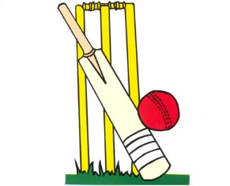

Junior Newcombeball- Smith West def Cabra West 15-3 1-15 15-3

Senior Newcombeball- SJP def Smithfield West 15-8 10-15 15-9

Junior Boys T-Ball- Fair West drew with Fair Hts 11-11

Junior Girls T-Ball- Cecil Hills def King Park 12-6

Junior Cricket- GPK def Fairfield West 84-66

Senior Cricket- GPK def Smithfield 71-59

Senior Boys Softball- Fairfield West def King Park 3-1

Senior Girls Softball- Fairfield West def Fair Hts 7-5

Senior Boys Touch - Cecil Hills def Fairfield West 2-1

Senior Girls Touch- Fair West drew with SJP 1-1

Junior Girls’ AFL- Cecil Hills def Fair Hts on FORFEIT

Senior Girls’ AFL- Governor Philip King def Bossley Pk 34-6

