Horsley Zone
2017
Summer PSSA
Grand Final Results
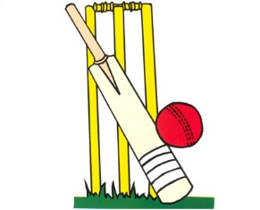

Junior Newcombeball- SJP drew with Harrington St 15-13 9-15

Senior Newcombeball- Harrington St def Smithfield West 15-7 15-11

Junior Boys T-Ball- Smithfield West drew with King Park 10-10

Junior Girls T-Ball- Smithfield drew with Smithfield West 11-11

Junior Cricket- Harrington St def GPK 82-75

Senior Cricket- Fairfield West def William Stimson 74-67

Senior Boys Softball- Fairfield West def William Stimson 11-0

Senior Girls Softball- Fairfield West def Canley Heights 8-1

Senior Boys League Tag- SJP def Fairfield West 4-3

Senior Girls Oztag- Fairfield West def Fairfield Heights 9-0

Junior Girls’ AFL- Fairfield Heights def Cecil Hills 7-6

Senior Girls’ AFL- Cecil Hills def Canley Heights 32-14

