Horsley Zone
2016
Summer PSSA
Grand Final Results
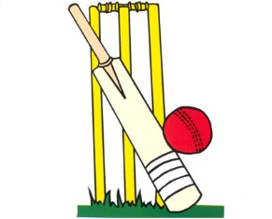

Junior Newcombeball- SJP def Harrington St 15-8 15-13

Senior Newcombeball- Cabramatta West def SJP 15-6 10-15 15-7

Junior Boys T-Ball- Bossley Park def Smithfield West 12-4

Junior Girls T-Ball- Smithfield def Prairievale 21-18

Junior Cricket- GPK def Cabramatta West 111-66

Senior Cricket- William Stimson def Fairfield West 80-42

Senior Boys Softball- Canley Heights def GPK 8-3

Senior Girls Softball- Fairfield West def Harrington St 9-1

Senior Boys Oztag- King Park def GPK 3-2

Senior Girls Oztag- Fairfield West def Harrington St 6-0

Junior Girls’ AFL- Canley Heights def Bossley Park 13-10

Senior Girls’ AFL- Canley Heights def Bossley Park 40-1

