Horsley Zone
2015
Summer PSSA
Grand Final Results
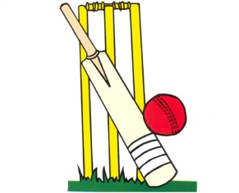

Junior Newcombe ball- SJP def Cabramatta West 2 sets to 1

Senior Newcombe ball- SJP drew with Cabramatta West 1-1

Junior Boys T-Ball- William Stimson def Bossley Park 15-11

Junior Girls T-Ball- Smithfield West def SJP 12-8

Junior Cricket- Fairfield West def GPK 80-45

Senior Cricket- William Stimson def Prairievale 67-38

Senior Boys Softball- Smithfield def Cecil Hills 4-2

Senior Girls Softball- Smithfield def Fairfield West 6-2

Senior Boys Oztag- Fairfield West def William Stimson 4-3

Senior Girls Oztag- William Stimson def Harrington St 1-0

Junior Girls’ AFL- Bossley Park def Canley Heights

Senior Girls’ AFL- Canley Heights def Bossley Park

