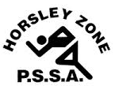
Horsley Zone
Girls Basketball Team
2022
Coach: Tim Platt
School: Harrington Street

School | Student
St Johns Park | Lily-Rose Hong
St Johns Park | Kali Poch
St Johns Park | Kaiyi Um
St Johns Park | Ruby Nguyen
St Johns Park | Tina Tran
Harrington Street | Jocelyn Taani
Canley Heights | Christina Hout
Smithfield West | Hadassah Pilato
Smithfield | Tamar Dikran
Smithfield | Ella Dumrul

The SSW Carnival
is to be held at
Bankstown Basketball Stadium,
Third Ave, Condell Park, on
Tuesday, 29th March, 2022

