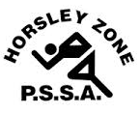
Horsley Zone
Girls Basketball Team
2021
Coach: Tim Platt
School: Harrington Street

School | Student
St Johns Park | Ava Vongsuthi
St Johns Park | Ruby Choi
King Park | Amina Mustafic
Smithfield | Tamar Dikram
Harrington Street | Charlize Duong
Harrington Street | Alivia Luu
Harrington Street | Norah Kalauni
Harrington Street | Elise Thai
Harrington Street | Leanne Nguyen
Harrington Street | April Le

The SSW Carnival
is to be held at
Bankstown Basketball Stadium,
Third Ave, Condell Park, on
Monday 22nd March, 2021

