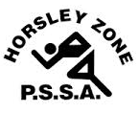
Horsley Zone
Girls Basketball Team
2024
Coach: Mr Tim Platt
School: Harrington Street Public School

School | Student
Smithfield West | Hadassah Pilato
King Park | Kristina K
Cecil Hills | Tasha Mallwarnchchi
Cecil Hills | Laura Borsos
Cecil Hills | Sarah Haddad
St Johns Park | Rachel Meoli
Harrington Street | Siera Palemene
Harrington Street | Olivia Casasola-Grinage
Harrington Street | Ayah Jindi

The SSW Carnival
is to be held at
Bankstown Basketball Stadium
on
Tuesday 2 April, 2024

