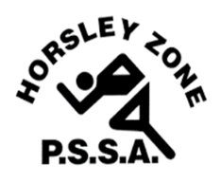
HORSLEY ZONE PSSA
Code of Conduct
for Parents/Spectators
Students participate in PSSA sports activities during school hours under the care and supervision of teachers. Parents and family members need to observe the following Code of Conduct to ensure that all students present at the event have an enjoyable experience.
1. Encourage participation by your child/children.
2. Encourage honest effort and skilled performance.
3. Remember that children play sport for their enjoyment.
4. Provide a model of good sports behaviour for your child to copy.
5. Never ridicule or yell at a child for making a mistake or losing a
game.
6. Be courteous in your communication with players, teachers, officials and sport administrators and show appreciation for their services.
7. Do not interfere with the conduct of any events.
8. Teach children to respect officials’ decisions.
Parent/spectators may attend PSSA games however, they must follow COVID-safe practices and physical distancing of 1.5 metres from other adults (including staff) must be maintained. Parents/spectators should also view games from specified areas set down for each sport.
I have read the Code of Conduct for parents/spectators and understand it.
I agree to act in accordance with the guidelines set out in the above Code of Conduct during my attendance at any Horsley Zone PSSA activity/event.
Child’s Name: _____________________________ Class: ________
Parent’s Name: __________________________________________
Parent’s Signature: ________________________ Date: _________

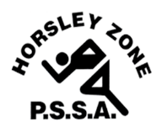
HORSLEY ZONE PSSA
Code of Conduct
for Students

1. Play sport for the fun of it.
2. Compete by the rules and always abide by the decisions made by a referee/umpire, touch judge or your teacher.
3. Try to the best of your ability at all times.
4. Control your temper. Make no criticism either by word or gesture.
5. Treat all students and adults with courtesy, fairness, tolerance and respect. Bad language, sledging and bullying on or off the area of play are never acceptable.
6. Be a good sport. Encourage fellow team members.
7. Play only when fit and always wear the correct safety equipment.
8. Conclude each game by congratulating the members of the opposing team. (No handshakes or high fives)
I have read the Code of Conduct carefully with my parents and understand it.
I am aware that not following the Code of Conduct will result in consequences, such as suspensions or removal from the team.
I agree to compete within the Code of Conduct at all times when involved in Horsley Zone PSSA activities/events.
Child’s Name: _____________________________ Class: ________
Child’s Signature: __________________________ Date: ________
Parent’s Signature: _________________________ Date: ________

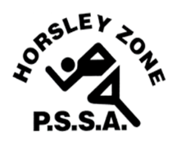
HORSLEY ZONE PSSA
Code of Conduct
for Teachers

- Encourage children to play sport for the fun of it and do not
over emphasise winning.

2. Create opportunities to teach sportsmanship.
3. Never ridicule children for making mistakes or losing.
4. Avoid over-playing talented players.
5. Ensure children use safety equipment and adhere to safety
guidelines.
6. Develop team respect and respect for the judgement of officials.
7. Learn and use current Horsley Zone PSSA rules.
8. Ensure that any student who may display signs of respiratory
illness prior to or during a game are to be excluded.
9. Ensure that the Duty of Care obligations that you hold as a
Department of Education representative extends to all students who
may be in attendance at a Horsley Zone event.

