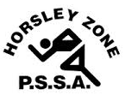
Horsley Zone
Boys Basketball Team
2021
Coach: Joe Misitano
School: Cecil Hills

School | Student
St Johns Park | Alexander Warne
St Johns Park | Leonardo Warne
Governor Philip King | Anthony Contreras
Smithfield | Jason Nguyen
Harrington Street | Nathaniel Tuki
Harrington Street | Zachariah Tuki
Cecil Hills | Evangel Chuna
Cecil Hills | Andre Yousif
Cecil Hills | Matthew Clark
Cecil Hills | Andreas Padilla

The SSW Carnival
is to be held at
Bankstown Basketball Stadium,
Third Ave, Condell Park, on
Monday 22nd March, 2021

