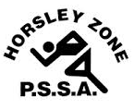
Horsley Zone
Boys Basketball Team
2020
Coach: William Trieu
School: Fairfield West Public School
School | Student
Smithfield | Alex Perrey, Sarp Vatansever
St Johns Park | Jobe Finau, Brian Phung, Leonardo Warne
King Park | Leon Chanthala
Fairfield West | Jozef Cluff
Smithfield West | Orlando Pau
Cecil Hills | Emiliano Cipriotte
Harrington St | Dylan Ramos

The SSW Carnival
is to be held at
Bankstown Basketball Stadium
on
23.03.20

