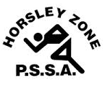
Horsley Zone
Athletics Carnival
2023

School | Points
GPK | 159
King Park | 147
Cecil Hills | 142
Harrington Street | 127
William Stimson | 107
St Johns Park | 92
Fairfield Heights | 80
Canley Heights | 76
Smithfield | 66
Prairievale | 60
Fairfield West | 52
Cabramatta West | 50
Smithfield West | 45
Edensor Park | 41
Bossley Park | 27
Kemps Creek | 14
Horsley Park | 12

C

