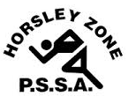
Horsley Zone
AFL Team
2020
Coach: Sheridan Coates
School: Fairfield Heights Public School

School | Student
Fairfield West Public School | Jozef Cluff
Fairfield Heights | Benjamin Sawyer  Jaylee Warren King  Taliah Whareaitu  Ayvah Magele
Cecil Hills | Mahoud Hamdan  Noor Hamdan
Bossley Park | Joseph Shamoon  Lucas Barkho  Kody Bojarski  Tristan To  Luka David

The SSW Carnival is to be held at
Monarch Oval (Fields Road, Macquarie Fields),
on
Wednesday 25th March

