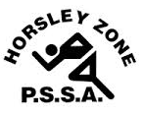
Horsley Zone
Opens Rugby League Team
2017
Coach: Mr Hormis
School: Fairfield West

School | Student
Fairfield Heights | Javahn King
King Park | Jesse Williams
GPK | Ezra Loau
Cecil Hills | Jack Dempsey
Fairfield West | Jaylen Skelton /  Will McNamara
Canley Heights | Tinirau Tofaeono

The SSW Carnival
is to be held at
Smith Park, East Hills
on
Wednesday 3rd May.

