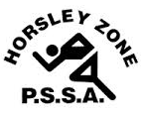
Horsley Zone
Opens Rugby League Team
2016
Coach: Ms McLean
School: Fairfield Heights

School | Student
Fairfield Heights | Johnathon F
Cabramatta West | Raymond L, Siaosi T, Emmanuel T
GPK | John T, Logan S
Cecil Hills | Ayman El C
King Park | Sila D, Albert D
Harrington St | Edward M
Smithfield West | Tupara H, Rose U
Fairfield West | Thomas K
Canley Heights | Angel M
Horsley Park | Charlie G, Harley G

The SSW Carnival
is to be held at
Smith Park, East Hills
on
Monday 2nd May.

