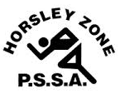
Horsley Zone
Hockey Representatives
2018
Convener: Mr Booth
School: Cabramatta West PS

School | Student
Horsley Park | Campbell Wilson
Fairfield West | Mohamad Rizvi
Harrington St | Joshua Smith

The SSW Carnival
is to be held at
Macarthur Hockey Complex
on
Tuesday 8th May.

