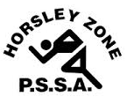
Horsley Zone
Girls Touch Team
2016
Coaches: Mr Ottmann & Ms.Tran
School: Fairfield West PS & Canley Heights PS

School | Student
Fairfield Heights | Rejana M & Sarsha M
Smithfield | Leela Ma Chong
Cecil Hills | Jasmine R & Jessica N
Kemps Creek | Jorja J & Bianca H
Fairfield West | Deana C, Tara-Jade O, Lakeisha K & Pauline S-R
Harrington St | April L

The SSW Carnival
is to be held at
Narellan Touch Fields
on
Monday 30th May.

