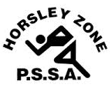
Horsley Zone
Girls Basketball Team
2019
Coach: Joe Misitano
School: Cecil Hills P.S

School | Student
King Park | Madelin Trostel
King Park | Rosa Piccinin
Bossley Park | Olivia Meneses
Harrington St | Mylan Dang
Cecil Hills | Ella Langi, Natalija Vidic, Jelena Dopudj, Violetta Velkovic, Sarah Debatista, Alana Mihajlovic

The SSW Carnival
is to be held at
Bankstown Basketball Stadium (Third Avenue Condell Park)
on
Monday 18th March

