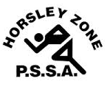
Horsley Zone
Girls Basketball Team
2017
Coaches: Mr Platt
School: Harrington St PS

School | Student
Fairfield Heights | Tina Lakic
Cabramatta West | Maleah Valahulu / Charity Luano
Fairfield West | Chloe Pamaka
Cecil Hills | Jasmina Dokic / Sorita Um
Smithfield | Zumra Vatansever
Canley Heights | Allie Hang
William Stimson | Megan Ly
Harrington St | Angela Tintor

The SSW Carnival
is to be held at
Bankstown Basketball Stadium,
Condell Park
on
Monday 5th June.

