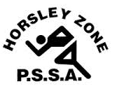
Horsley Zone
Girls Basketball Team
2016
Coach: Mr Urbancic
School: Cabramatta West PS

School | Student
Cecil Hills | Athida / Jasmina
Cabramatta West | Samara / Maleah
William Stimson | Charniah
Smithfield | Kimberley / Charlotte / Emily
Fairfield West | Angelina
Harrington St | Cynthia

The SSW Carnival
is to be held at
Bankstown Basketball Stadium
on
Monday 7th March.

