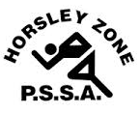
Horsley Zone
Boys Touch Team
2018
Coach: Mr Ottmann School: Fairfield West PS

School | Student
Fairfield Heights | Angel Reid
Cabramatta West | Vegas Tuitama, Terry Liu, Kevin Khuu
Smithfield | Luke Letoa
GPK | Corey Lloyd
Fairfield West | George Koborsi
Prairievale | Brayden Dodd
Bossley Park | Harrison Karananos
Smithfield West | Moses Fetu
Canley Heights | Chayce Roberts

The SSW Carnival
is to be held at
Vale of Ah, Milperra
on
Monday 21st May.

