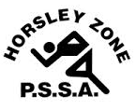
Horsley Zone
Boys Touch Team
2016
Coach: Mr Ottmann
School: Fairfield West PS
* Updated 16/3/16
School | Student
Fairfield Heights | Javahn K / Dimitrius T
Cabramatta West | Zaidus M
William Stimson | Amir A
GPK | Logan S / James R
Cecil Hills | Tristan C
Harrington St | Joseph P
King Park | Jett M-S
Bossley Park | Bryce N
Horsley Park | Charlie G
Canley Heights | Chris C

The SSW Carnival
is to be held at
Vale of Ah, Milperra
on
Monday 16th May.

