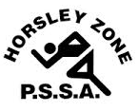
Horsley Zone
Boys Basketball Team
2019
Coach: William Trieu
School: Fairfield West Public School

School | Student
William Stimson | Curtis Evic
Cabramatta West | Jordan Ratcliff
St Johns Park | Josh Tierney, Sope Vlae
Smithfield | Tennyson Ly
Harrington Street | Frank Tran, Kaiden Vo, Lachlan Ly
Governor Phillip King | Liam Tanner
Cecil Hills | Kingston Kandalaft

The SSW Carnival
is to be held at
Bankstown Basketball Stadium (Third Avenue Condell Park)
on
Monday 18th March

