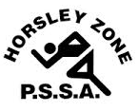
Horsley Zone
Boys Basketball Team
2017
Coach: Mr Misitano
School: Cecil Hills PS

School | Student
Cecil Hills | Orlando Sam
Bossley Park | Nahvroy Chuna
GPK | Jordan Kotevski
Fairfield Heights | Javahn King, Andrew Le
Smithfield | Edward Ly, Sean Cook
Cabramatta West | Zaidas Muagututia
Canley Heights | Christopher Nguyen, Sasha Drca

The SSW Carnival
is to be held at
Bankstown Basketball Stadium
on
Monday 5th June.

