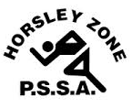
Horsley Zone
Boys Basketball Team
2016
Coach: Mr Misitano
School: Cecil Hills PS

School | Student
Cecil Hills | Colin D, Jacob L, Orlando S, Mitchell T
Bossley Park | Marcus C, Phoenix L
GPK | Jordan K, Ryan L, Isaac L
King Park | Jett M-S

The SSW Carnival
is to be held at
Bankstown Basketball Stadium
on
Monday 7th March.

