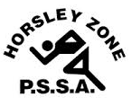
Horsley Zone
Athletics Carnival
2022

School | Points
Cecil Hills | 139
King Park | 128
Harrington Street | 123
St Johns Park | 112
GPK | 108
Prairievale | 53
Smithfield West | 53
William Stimson | 50
Smithfield | 48
Fairfield Heights | 40
Fairfield West | 38
Canley Heights | 36
Cabramatta West | 34
Bossley Park | 25
Horsley Park | 15
Kemps Creek | 9
Edensor Park | 4

C

