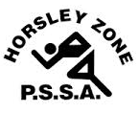
Horsley Zone
11’s Rugby League Team
2017
Coach: Mr Hormis
School: Fairfield West

School | Student
Fairfield Heights | Dimitrius T, Angel R
Cabramatta West | Zaidas M, Isaiah T
GPK | Lance T, Tana I, Corey L
Harrington St | David T, Blake W, Cyrus T
Bossley Park | Harrison K
Fairfield West | Lee-Jay S, Phoenix E, William C
Canley Heights | Noaia’ehanisi T, Vili R, Willie H, Luke L

The SSW Carnival
is to be held at
Smith Park, East Hills
on
Thursday 30th March.

