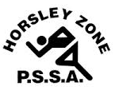
Horsley Zone
11’s Rugby League Team
2016
Coach: Ms McLean
School: Fairfield Heights

School | Student
Fairfield Heights | Dimitrius T, Javahn K, Angel R
Cabramatta West | Zaidas M
William Stimson | Chris B, Amir A
GPK | Lance T, Ezra L, James R
Smithfield | Samson N
Harrington St | Timothy W
Smithfield West | Hansi, Levy A, Pfieffer F
Fairfield West | Will M
Canley Heights | LJ F, Tinirau T

The SSW Carnival
is to be held at
Smith Park, East Hills
on
Thursday 28th April.

