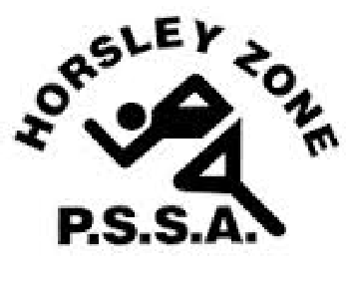

History of the Horsley Zone PSSA

Champion Schools

1. Cricket

2. Rugby League

3. Tag / Touch

4. Softball / T-Ball

5. Basketball

6. Newcombeball

7. Football

8. AFL

9. Netball

10. Swimming

11. Cross Country

12. Athletics

13. Overall Summer / Winter Champion Schools



Cricket

1986- Fairvale 1987- Fairvale

1988- Harrington St 1989- Smithfield West

1990- Smithfield 1991- Smithfield West

1992- Smithfield West 1993- Fairfield West

1994- Smithfield 1995-

1996- 1997-

1998- GPK

1999-

2000-

2001- GPK

2002- GPK

2003- GPK

2004- GPK

2005- GPK

2006- GPK

2007- GPK

2008-

2009- GPK

2010- GPK

2011- GPK 2012-

2013- Fairfield West 2014- GPK

2015- Fairfield West 2016- Governor Philip King

2017- William Stimson 2018- Governor Philip King

2019- Governor Philip King 2020- N/A

2021- N/A 2022- N/A

2023- King Park / SJP



Rugby League

1992- Fairfield West 2023- Fairfield West

1993- GPK

1994- Bossley Park

1995- GPK

1996- William Stimson

1997- GPK & William Stimson

1998- GPK & Prairievale

1999- GPK

2000- GPK

2001- GPK

2002- GPK

2003- William Stimson

2004 GPK

2005- Fairfield West

2006- GPK

2007- Fairfield West

2008- Canley Heights

2009- Fairfield West

2010- Smithfield West

2011- Canley Heights

2012- Smithfield West

2013- GPK

2014-

2015- Fairfield West

2016- Fairfield West

2017- Fairfield West

2018- Fairfield West

2019- GPK

2020- N/A

2021- N/A

2022- Fairfield West

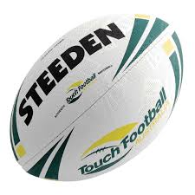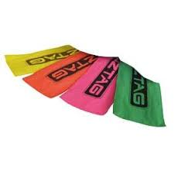

Tag

2010- Harrington St

2011- Smithfield West

2012- William Stimson

2013- William Stimson

2014- Fairfield West

2015- Fairfield West / William Stimson

2016- Governor Philip King

2017- Fairfield West / SJP

Touch

2018- Fairfield West

2019- Fairfield West

2020- N/A

2021- N/A

2022- N/A

2023- GPK



Softball / T-Ball

1998- St Johns Park

1999-

2000-

2001-

2002-

2003-

2004-

2005-

2006-

2007-

2008-

2009-

2010-

2011-

2012- Smithfield

2013- Smithfield

2014- William Stimson

2015- Fairfield West

2016- Fairfield West

2017- Fairfield West

2018- Cecil Hills

2019- Fairfield Heights

2020- N/A

2021- N/A

2022- N/A

2023- Cecil Hills



Basketball

1998- Cabramatta West

1999- Cabramatta West

2000- Canley Heights

2001- Canley Heights

2002- GPK

2003- Fairfield West

2004- Cecil Hills

2005- Cecil Hills

2006- Cecil Hills

2007- GPK

2008- Cecil Hills

2009- Cabramatta West & Harrington St

2010- Harrington St

2011- Cabramatta West

2012- GPK

2013- Cecil Hills

2014- Cabramatta West & Harrington St

2015- Cabramatta West

2016- Cabramatta West

2017- Cabramatta West

2018- St Johns Park

2019- Cabramatta West

2020- N/A

2021- N/A

2022- St Johns Park

2023- William Stimson



C:\Program Files (x86)\Microsoft Office\MEDIA\CAGCAT10\j0301480.wmfNewcombeball

1986- Harrington St

1992- Harrington St

2003- Cecil Hills

2012- Cabramatta West

2013- Cabramatta West

2014- Cabramatta West

2015- Cabramatta West

2016- St Johns Park

2017- GPK

2018- Smithfield West

2019- St Johns Park

2020- N/A

2021- N/A

2022- N/A

2023- SJP



Football

1998- GPK 2020- N/A

1999- Bossley Park 2021- N/A

2000- Bossley Park 2022- Cecil Hills

2001- William Stimson 2023- King Park

2002- GPK

2003- King Park

2004- GPK

2005- GPK

2006- GPK

2007- Cecil Hills

2008- GPK

2009- GPK

2010- GPK

2011 - GPK

2012- William Stimson

2013- William Stimson

2014- Bossley Park

2015- Prairievale

2016- Cecil Hills

2017- Cecil Hills

2018- Cecil Hills

2019- Cecil Hills



AFL

2012- Fairfield Heights

2013- Cecil Hills

2014- Cecil Hills

2015- Bossley Park

2016- Bossley Park

2017- Cecil Hills

2018- Cecil Hills

2019- Fairfield Heights

2020- N/A

2021- N/A

2022- St Johns Park

2023- GPK



Netball

1998- Prairievale 2020- N/A

1999- Prairievale 2021- N/A

2000- 2022- St Johns Park

2001- 2023- GPK

2002-

2003-

2004-

2005-

2006-

2007-

2008-

2009-

2010-

2011-

2012- GPK

2013- GPK

2014- GPK

2015- GPK

2016- Smithfield

2017- GPK

2018- Fairfield West

2019- Fairfield Heights



Swimming

1997- Bossley Park 2022- St Johns Park

1998- Bossley Park 2023- Cecil Hills

1999- Bossley Park

2000- Bossley Park

2001- St Johns Park

2002- GPK

2003- Fairfield West

2004- GPK

2005- GPK

2006- GPK

2007- Cecil Hills

2008- Cecil Hills

2009- Cecil Hills

2010- Harrington St

2011- Harrington St

2012- GPK

2013- Harrington St

2014- Harrington St

2015- Harrington St

2016- Smithfield

2017- Smithfield

2018- Smithfield

2019- Harrington St

2020- Harrington St

2021- Harrington St



Cross Country

1982- King Park 2023- Cecil Hills

1983- Canley Heights

1984- King Park

1985- King Park

1986- King Park

1987- Fairfield West

1988- GPK

1989- GPK

1990- King Park

1993- SJP

2014- King Park

2015- Cecil Hills

2016- St Johns Park

2017- King Park

2018- Cecil Hills

2019- Cecil Hills

2020- N/A

2021- Cecil Hills

2022- Cecil Hills

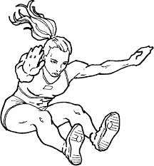

Athletics

|  |  |
| --- | --- |
| 1973- Canley Hts | 1974- Canley Hts |
| 1975- Harrington St | 1976- Canley Hts |
| 1977- Fairfield West | 1978- Fairfield West |
| 1979- Fairfield West | 1980- Canley Hts |
| 1981- Fairfield West | 1982- Canley Vale |
| 1983- Harrington St | 1984- Canley Hts |
| 1985- | 1986- |
| 1987- | 1988- Fairfield West |
| 1989- Fairfield West | 1990- |
| 1991- | 1992- |
| 1993- | 1994- GPK |
| 1995- Canley Hts | 1996- Canley Hts |
| 1997- | 1998- GPK |
| 1999- GPK | 2000- St Johns Park |
| 2001- GPK | 2002- GPK |
| 2003- GPK | 2004- |
| 2005- | 2006- |
| 2007- | 2008- GPK |
| 2009- | 2010- |
| 2011- | 2012- |
| 2013- | 2014- |
| 2015- King Park | 2016- Harrington St |
| 2017- Fairfield West | 2018- Fairfield West |
| 2019- Cecil Hills | 2020- N/A |
| 2021- N/A | 2022- Cecil Hills |
| 2023- GPK |  |





HORSLEY ZONE PSSA

OVERALL CHAMPION SCHOOL

|  |  |  |
| --- | --- | --- |
| YEAR | SUMMER | WINTER |
| 2016 | Cabramatta West | Smithfield |
| 2017 | St Johns Park | Cecil Hills |
| 2018 | Fairfield West | Cecil Hills |
| 2019 | Smithfield West | Fairfield Hts / GPK |
| 2020 | N/A | N/A |
| 2021 | N/A | N/A |
| 2022 | N/A | St Johns Park |
| 2023 | GPK | GPK |
| 2024 |  |  |
| 2025 |  |  |
| 2026 |  |  |
| 2027 |  |  |
| 2028 |  |  |
| 2029 |  |  |
| 2030 |  |  |