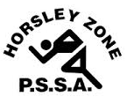
Horsley Zone
Boys Touch Team
2022
Coach: Matthew Kirby
School: Smithfield West Public School

School | Student
Cecil Hills | Aston Hughes
Governor Philip King | Damien Moser
Governor Philip King | Kaline Masitabua
Governor Philip King | Jeremiah Mataniu
William Stimson | Kelepi Sisifa
Smithfield West | Viliami Tuigamala
Smithfield West | Zayne Honeysett
Smithfield West | Braxton Pignat
Harrington St | Jardi Ikamui
Harrington St | Deucaleon Ikamui

The SSW Carnival
is to be held at
The Vale of Ah,
Milperra
on
Wednesday 9th March

