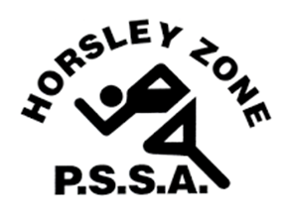
HORSLEY ZONE PSSA REPRESENTATIVE
PERMISSION NOTE 2023

Name of Student
School
Sport
Trial Details | I give permission for my child to participate in the  Sydney South West (Insert Sport) Championships  to be held at:  Location :(Insert Location)  Date: (Insert Date)  Time: (Insert Time)  Cost in 2023 Swimming $20.00 (includes a HZ Cap)  Cross Country $15.00, Athletics $15.00,  Rugby League/Softball $30.00 per player (includes socks)  Football, Touch, Union, Basketball,  Netball $30 per player for teams  Individual students see SSW website (Hockey, AFL)  (keep what is relevant)  Swimming and Athletics ensure you put the  parent entry fee on note  _________________________ ______________  Signature of Parent/Carer Date
Emergency Contact | In case of illness or injury to my child during the  Championships/Trials the following person should be  contacted if I am not in attendance or unable to be contacted:  Name: ___________________________________  Phone: (Home) ____________________________  (Mobile) _________________________________
…………………………… | ………………………………………………………………………………
 | PARENTS/CARERS TO KEEP THE INFORMATION BELOW
Location/Date/Time  of the event | ??????
Travel | Parents/Carers will need to organise travel to and from the venue on the day of the Regional trials.
Uniform | Insert Relevant Details ????
Things needed  on the day | Insert Relevant Details ????
Training Details | Location: ?????  Dates: ?????  Time: ?????
Coach/Manager  Contact Details | Name: ????  School Number: ???? Mobile Number: ??? (Optional)

