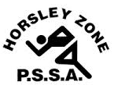
Horsley Zone
Boys Basketball Team
2022
Coach: Joe Misitano
School: Cecil Hills P.S.

School | Student
GPK | Paul Sebo
GPK | Jonathan Davis
Chi | Ali Raof
SJP | George Tangi
SJP | Edward Ong
SJP | Isaac Choi
SJP | Leon Ma
SJP | Andre Duong
SJP | AJ Sisavanh
SJP | Eric Lim

The SSW Carnival
is to be held at
Bankstown Stadium,
1 Third Ave, Condell Park NSW 2200
on
Tuesday 29 March 2022

